**Module 2: Java Script and SQL**

**JAVA SCRIPT**

1Write a Java Script to find the n prime number.

<html>

<head>

<script>

function as() {

var userValue = document.getElementById("i").value;

var value = 0, result = [];

for (var i = 0; i < userValue; i++) {

value = Prime(value);

result.push(value);

}

document.getElementById("returnValue").innerHTML = result[userValue-1];

}

function Prime(value) {

if (value > 2) {

var i, q;

do {

i = 3;

value += 2;

q = Math.floor(Math.sqrt(value));

while (i <= q && value % i) {

i += 2;

}

} while (i <= q);

return value;

}

return value === 2 ? 3 : 2;

}

</script>

</head>

<body>

Input value: <input type="text" name="inputValue" id="i"/>

<button onclick="as()">Prime number</button>

<div id="returnValue">Test: </div>

</body>

</html>

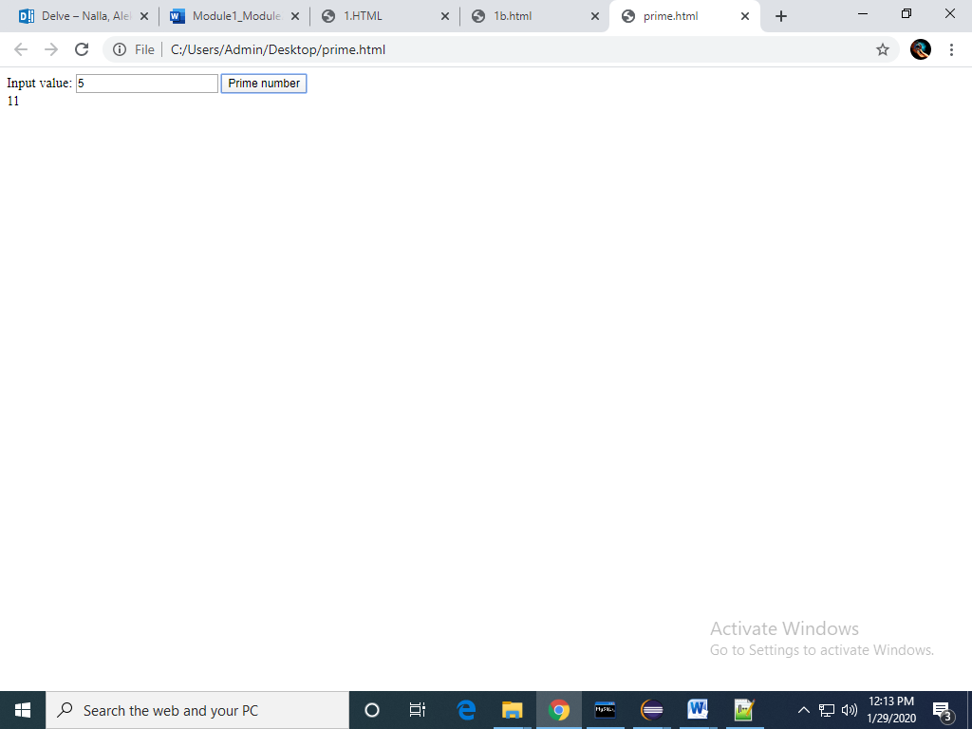

**2.SQL**

1. Write a query to display customer number, customer’s firstname , account number where the account status is terminated. Display the records sorted in ascending order based on customer number and then by account number.

a.)select cm.customer_number,cm.firstname,am.account_number

from

customer_master cm join account_master am on cm.customer_number=am.customer_number

where

am.account_status='terminated'

order by cm.customer_number,am.account_number;

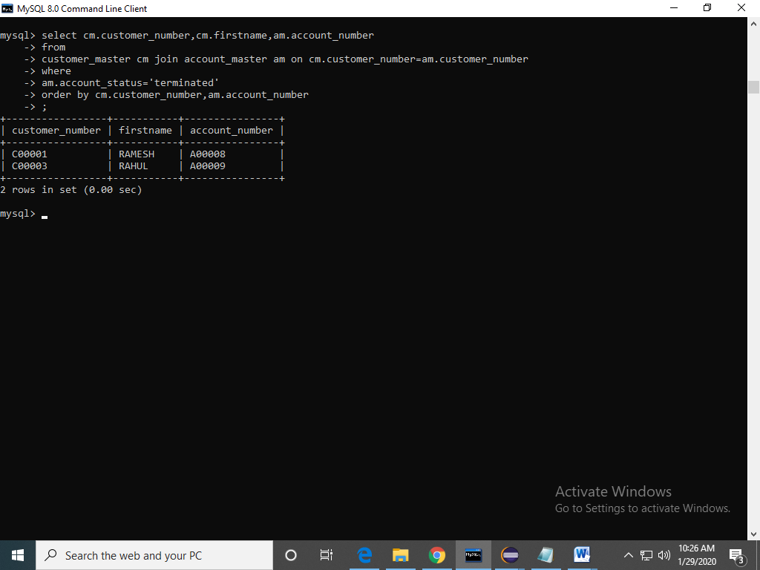

b.Write a query to display the number of accounts opened in each city. The query should display the Branch city and the number of No_of_Accounts for the branch city where we don’t have any accounts opened display 0. Display the records in the sorted order based on branch city.

b.) select bm.branch_city ,count(am.account_number) as count_account_number

from

branch_master bm left join account_master am on am.branch_id=bm.branch_id

group by

bm.branch_city

order by

bm.branch_city;

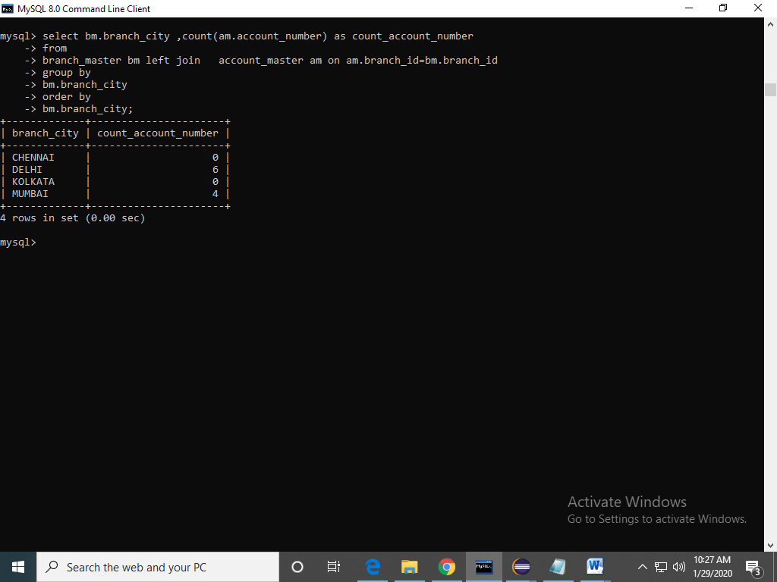

cWrite a query to display the customer number, customer firstname, customer lastname who has taken loan from more than 1 branch. Display the records sorted in order based on customer number.

c. )select cm.customer_number,cm.firstname,cm.lastname

from

customer_master cm join loan_details ld on ld.customer_number=cm.customer_number

group by

ld.customer_number

having count(ld.branch_id)>1

order by

cm.customer_number;

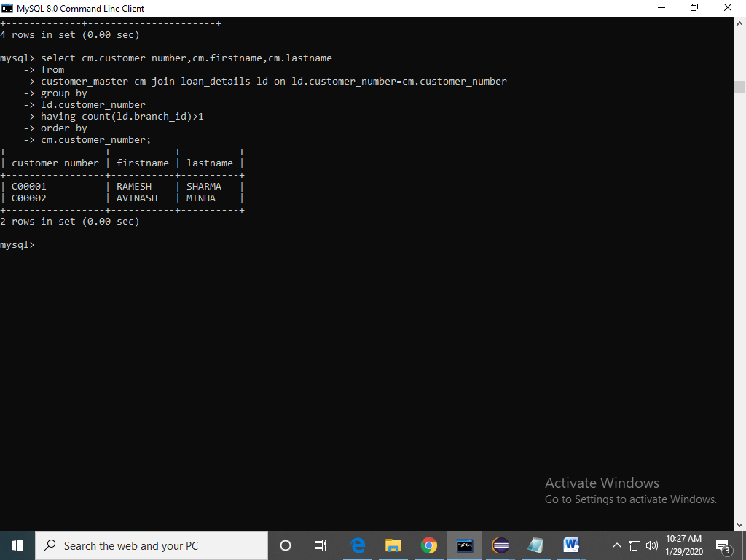

d.Write a query to display the number of clients who have asked for loan but they don’t have any account in the bank though they are registered customers. Give the count an alias name of Count.

d.)select count(cm.customer_number) as count

from

loan_details ld join customer_master cm on ld.customer_number=cm.customer_number

WHERE cm.customer_number NOT IN (SELECT customer_number FROM account_master);

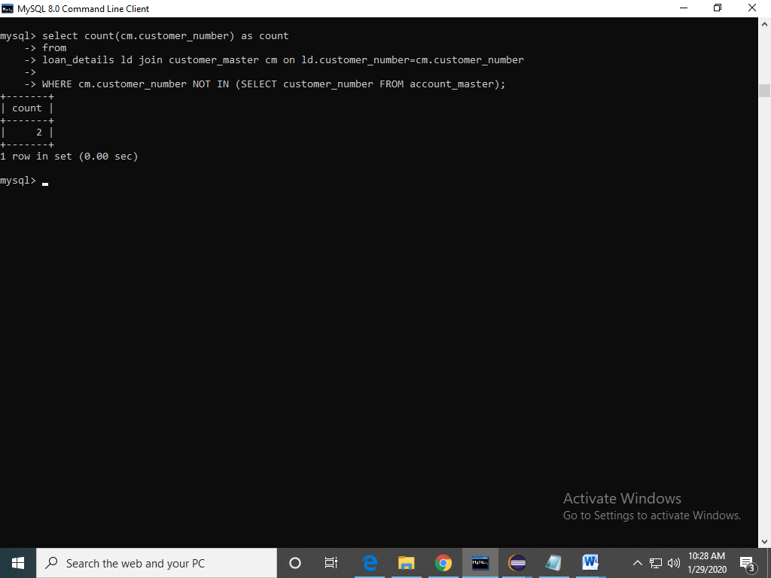

e.Write a equerry to display customers firstname, city and account number whose occupation are not business , Services or Student. Display the records sorted in ascending order based on customer firstname and by account number.

e.)select cm.firstname,cm.customer_city,am.account_number

from

customer_master cm join account_master am on cm.customer_number=am.customer_number

where

cm.occupation<>'service' and cm.occupation<>'student' and cm.occupation<>'business'

order by

cm.firstname,am.account_number;

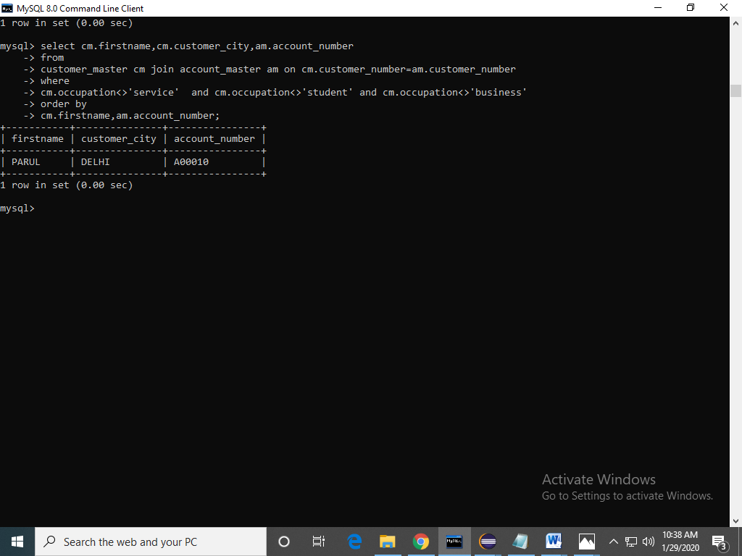

MODULE 1:

1(a):

<html>

<head>

<script>

var p1=0

function change_text(){

if(p1==0){

document.getElementById("a").innerHTML="WELL DONE!.......";

P1=1;

}

else{

document.getElementById("a").innerHTML="hello!.......";

}

}

</script>

</head>

<body>

<div id="a">Hello</div>

<input id="mybutton" type="button" value="Change Text" onclick="change_text()">

</body>

</html>

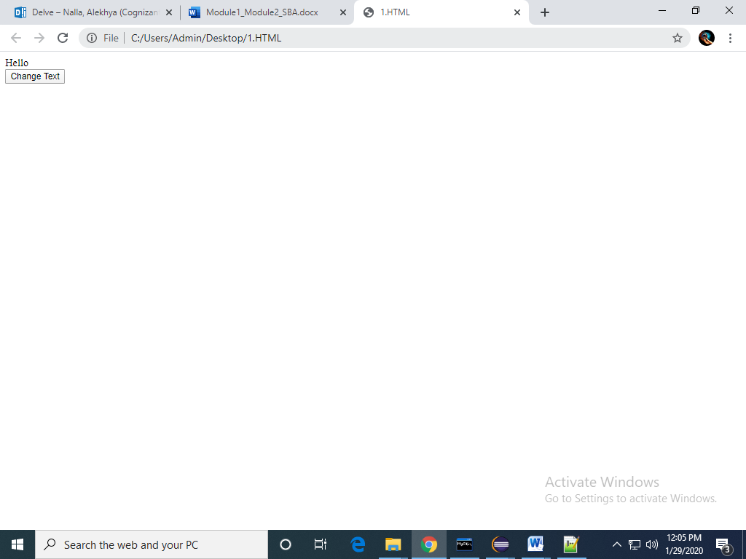

1(b)

<html>

<head>

<script>

var p1=0

function change_days(){

var a=document.getElementById("m");

if(a.innerHTML==="Sunday"){

a.innerHTML="Monday";

}else if(a.innerHTML==="Monday"){

a.innerHTML="Tuesday";

}else if(a.innerHTML==="Tuesday"){

a.innerHTML="Wednesday";

}

else if(a.innerHTML==="Wednesday"){

a.innerHTML="Thursday";

}

else if(a.innerHTML==="Thursday"){

a.innerHTML="Friday";

}

else if(a.innerHTML==="Friday"){

a.innerHTML="Saturday";

}

else{

a.innerHTML="Sunday";

}

}

</script>

</head>

<body>

<div id="m">Sunday</div>

<input id="mybutton" type="button" value="Change Text" onclick="change_days()">

</body>

</html>

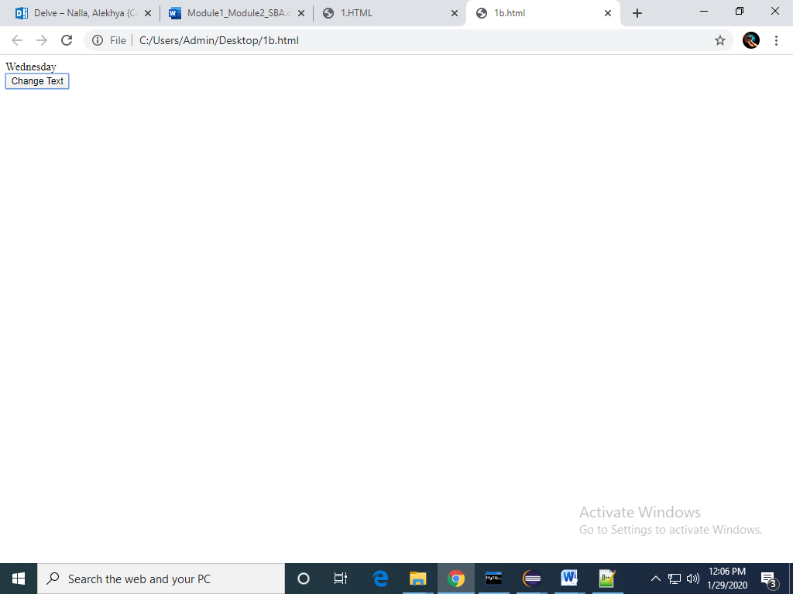

2.a. Create a newHTML-document with an unordered list element, a text-box,and a button that says “Add.”

b. Add JavaScript(and/or jQuery)that appendsa new <li> element to the unordered list when the button is clicked. The text of the new li-element should correspond to the text entered by the user in the text-box. Make sure thatthe content of the text-box is cleared when the button is clicked to be ready for new input from the user.

<!DOCTYPE html>

<html>

<head>

</head>

<body>

<div id="myDIV" class="header">

<input type="text" id="myInput" placeholder="Add">

<button onclick="newElement()" class="addBtn">Add</button>

</div>

<ul id="UL">

</ul>

<script>

var myNodelist = document.getElementsByTagName("LI");

var i;

for (i = 0; i < myNodelist.length; i++) {

var span = document.createElement("SPAN");

var txt = document.createTextNode("\u00D7");

span.className = "close";

span.appendChild(txt);

myNodelist[i].appendChild(span);

}

function newElement() {

var li = document.createElement("li");

var inputValue = document.getElementById("myInput").value;

var t = document.createTextNode(inputValue);

li.appendChild(t);

document.getElementById("UL").appendChild(li);

document.getElementById("myInput").value = "";

var span = document.createElement("SPAN");

var txt = document.createTextNode("\u00D7");

span.className = "close";

span.appendChild(txt);

li.appendChild(span);

for (i = 0; i < close.length; i++) {

close[i].onclick = function() {

var div = this.parentElement;

div.style.display = "none";

}

}

}

</script>

</body>

</html>

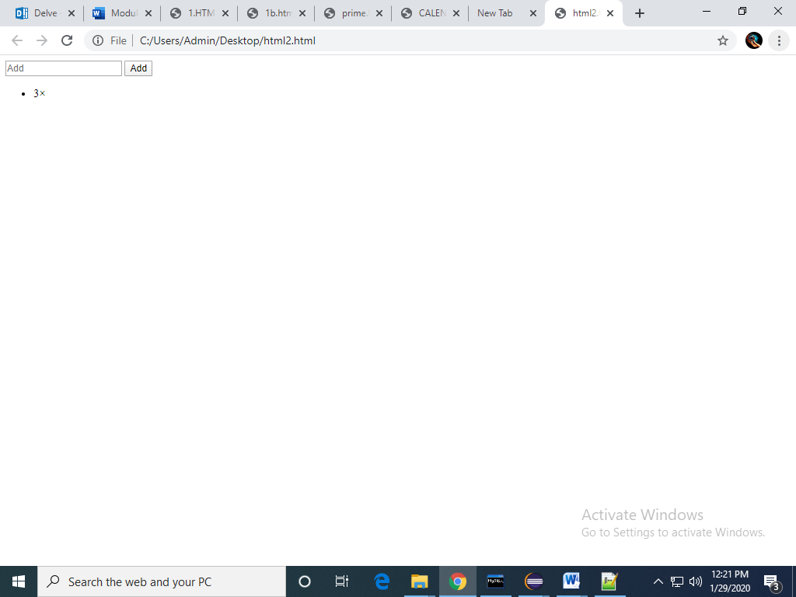

3. Using CSS properties create a calendar with following Calender Template:

<html>

<head>

<style>

* {box-sizing: border-box;}

ul {list-style-type: none;}

body {font-family: Verdana, sans-serif;}

.month {

padding: 50px 25px;

width: 100%;

background: #F08080;

text-align: center;

}

.month ul {

margin: 0;

padding: 0;

}

.month ul li {

color: white;

font-size: 20px;

text-transform: uppercase;

letter-spacing: 3px;

}

.month .prev {

float: left;

padding-top: 10px;

}

.month .next {

float: right;

padding-top: 10px;

}

.weekdays {

margin: 0;

padding: 10px 0;

background-color: #ddd;

}

.weekdays li {

display: inline-block;

width: 13.6%;

color: #666;

text-align: center;

}

.days {

padding: 10px 0;

background: #eee;

margin: 0;

}

.days li {

list-style-type: none;

display: inline-block;

width: 13.6%;

text-align: center;

margin-bottom: 5px;

font-size:12px;

color: #777;

}

.days li .active {

padding: 5px;

background: #FFC0CB;

color: white !important

}

@media screen and (max-width:720px) {

.weekdays li, .days li {width: 13.1%;}

}

@media screen and (max-width: 420px) {

.weekdays li, .days li {width: 12.5%;}

.days li .active {padding: 2px;}

}

@media screen and (max-width: 290px) {

.weekdays li, .days li {width: 12.2%;}

}

</style>

</head>

<body>

<h1>CSS Calendar</h1>

<div class="month">

<ul>

<li class="prev">&#10094;</li>

<li class="next">&#10095;</li>

<li>

MAY<br>

<span style="font-size:18px">2017</span>

</li>

</ul>

</div>

<ul class="weekdays">

<li>Mon</li>

<li>Tue</li>

<li>Wed</li>

<li>Thu</li>

<li>Fri</li>

<li>Sat</li>

<li>Sun</li>

</ul>

<ul class="days">

<li>1</li>

<li>2</li>

<li>3</li>

<li>4</li>

<li>5</li>

<li>6</li>

<li>7</li>

<li>8</li>

<li>9</li>

<li><span class="active">15</span></li>

<li>11</li>

<li>12</li>

<li>13</li>

<li>14</li>

<li>15</li>

<li>16</li>

<li>17</li>

<li>18</li>

<li>19</li>

<li>20</li>

<li>21</li>

<li>22</li>

<li>23</li>

<li>24</li>

<li>25</li>

<li>26</li>

<li>27</li>

<li>28</li>

<li>29</li>

<li>30</li>

<li>31</li>

</ul>

</body>

</html>

